##(A or B)(G or U)### (HiSOR proposal number) | BL-## (HiSOR beamline number)

Title Should Be Capitalized for Each Initial Letter
Author’s Nameª and Author’s Name^{b}
ªAuthor’s Affiliations with Complete Address
Continue Here
^{b}Author’s Affiliations with Complete Address
Continue Here

Keywords: Enter keywords.
The main text is written from here with this font (Times New Roman) and size (10.5 pt) and line spacing (normal). You can use this template, just overwrite it.
If you start new paragraph, please use “Enter” or "Return" key on your keyboard. The indent is automatically inserted at the start of this paragraph.
If you want to make a line feed without indent, we can enter “Shift + Enter” keys. This is the result of the procedure.
Reference number should be shown using brackets like [1]. If you want to refer to several references, you can do it like [1, 2] or [3-5].
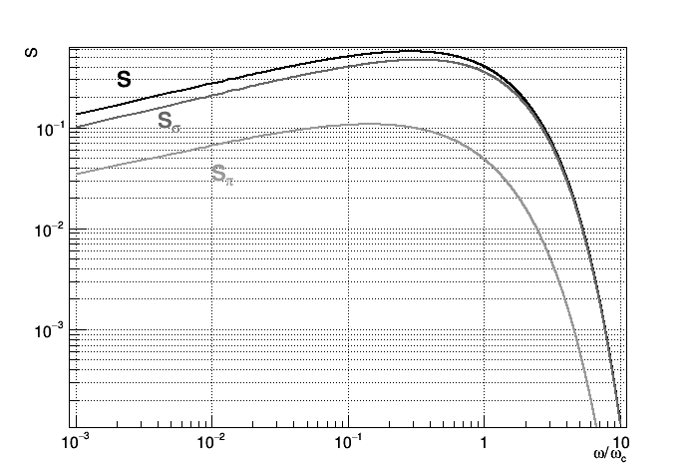
FIGURE 1. This is a style of figure caption. The font size is 9 pt. The figure is centered as shown above. The plots in this figure are calculated from eq. 1 [6].

The main text continues from here. Below is an example of Table. The table format is described in the caption.

TABLE 1. This is the style of Table captions. Font size is 9 pt. Column titles are capitalized for each letter and bold-font. Row names are capitalized for each letter and left-justified. Contents are centered.
Column Title | Column Title | Column Title
Row Name | x | y
Row Name | x | y
Row Name | x | y

Below is an example equation created with Office built-in equations. To make numbering of the equation, the table tool is used with a setting of “No Border”. The equation is centered in the column, and the number is righted. This equation shows a spectral function of the synchrotron radiation for a short bending magnet [6]. In the "paragraph" setting use 6pt spacing above and below the equation.
$$S\left(\frac{ω}{ω_{c}}\right)=\frac{9\sqrt{3}ω}{8πω_{c}}\int_{ω/{ω_{c}}}^{∞}{K_{5/3}\left(z'\right)dz'}.$$ | (1)
If you do not use the numbering of equations, you can just enter the equation like:
$$S\left(\frac{ω}{ω_{c}}\right)=\frac{9\sqrt{3}ω}{8πω_{c}}\int_{ω/{ω_{c}}}^{∞}{K_{5/3}\left(z'\right)dz'}.$$
The equation is automatically centered in this case.
You can also put an equation in the main text like, $γβ-α^{2}=1$.
REFERENCES
1. A. Brown and B. Austin, The Physics, Publisher City: Publisher Name, 1995, pp. 125-140.
2. A. Brown and B. Austin, Appl. Phys. Letters 166, 1125-1127 (2045).
3. L. Liu, “Title of Chapter,” in Classical Optics, edited by J. L. Miller, Publisher City: Publisher Name, 2018, pp. 105-182.
4. C. D. Smith and E. F. Jones, “First Commissioning Report of Fermitron Circular Collider” in Synchrotron Radiation Instrumentation 2050, edited by G. H. Cooper et al., AIP Conference Proceedings 4289, American Institute of Physics, Melville, NY, 2051, pp. 855-857.
5. I. J. David, "Effects of Sugars on Tea and Coffee", Ph.D. Thesis, Hiroshima University, 1942.
6. A. Hofmann, “Characteristics of Synchrotron Radiation” in Proceedings of CERN Accelerator School, edited by S. Turner, CERN 98-04, CERN, Genève, 1998, pp. 1-44.

Please submit your activity report in the Microsoft Word format as well as in the pdf format via e-mail addressed to hisor_at_hiroshima-u.ac.jp (_at_==>@). The pdf file is needed to confirm the format as you edited on your computer. Microsoft Word format may be modified depending on the OS or the Microsoft Word version.
(Please delete this text box on submission.)

