Title is Times New Roman 18 pt in Bold
Author's Nameª, Author's Name in 14 pt^{b}
ªReplace this text with authors' affiliations, 11 pt, italic
^{b}If more than one affiliation is needed, they should be indicated by superscript
letters, a, b, c, etc. as shown above

The abstract should be one page to fit into the A4 paper size (210×297mm) with a margin of 25 mm (top, bottom, right and left). You can use this template to make a draft for your abstract. Please use Times New Roman 11pt for the main text. The line spacing is now fixed to 16 pt. The reference number in the main text should be in the square bracket like this [1]. After editing, please make a pdf file for submission. Should you use special fonts, please embed them in the pdf file [2].
Below is an example of equation (1) created using MathType 7.0 Equation [3]. If you insert equations, please adjust the line spacing.

(1)

You can include figures as shown below. If there are two figures, you can label them like Fig. 1(a) and 1(b). Figures should be clearly represented in a grey scale.

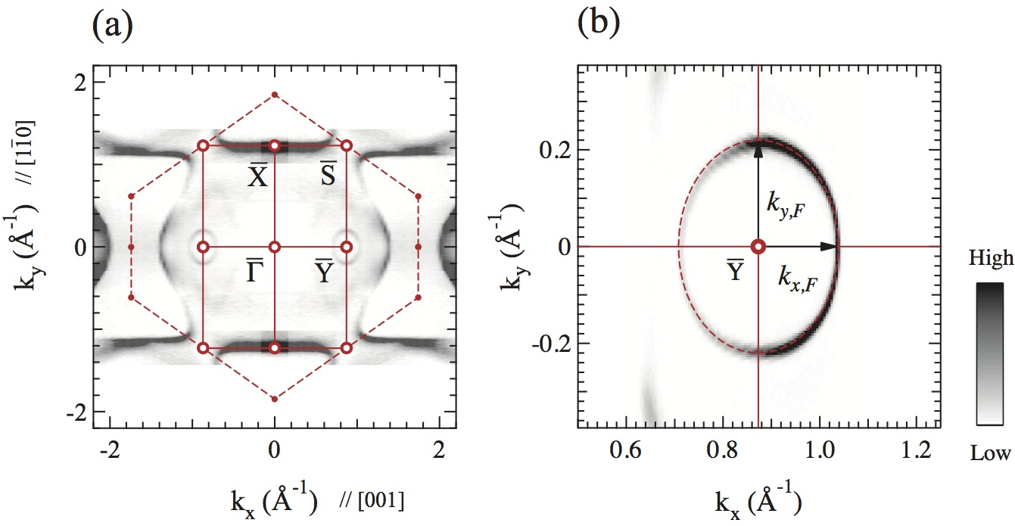

Fig. 1. This is the Style for Figure Captions. All text should be 10 pt. Justify this text under the figure. If there are several figures, please label them as (a), (b), ....

References
[1] J. Jiang, S.S. Tsirkin, K. Shimada, et al. Phys. Rev. B 89, 085404 (2014).
[2] https://helpx.adobe.com/acrobat/using/pdf-fonts.html
[3] http://www.dessci.com/en/products/mathtype/

