The title is like this style
Author's Nameª and Author's Name^{b}
ªReplace this text with authors' affiliations (use complete addresses)
^{b}If more than one affiliation is needed, they should be indicated by superscript
letters, a, b, c, etc. as shown above

This is the standard font (Times New Roman) and layout for the individual paragraphs. The abstract should be one page to fit into the A4 paper size (210×297mm). You can use this template to make a draft for your abstract. The reference number in the main text should be in the square bracket [1]. After editing, please make a pdf file for the web submission. Should you use special fonts, please embed them in the pdf file [2].
Below is an example of equation created using MathType 6.0 Equation [3]. In this template, the line spacing is fixed to 16 pt. If you insert equations, please adjust the line spacing.

(1)

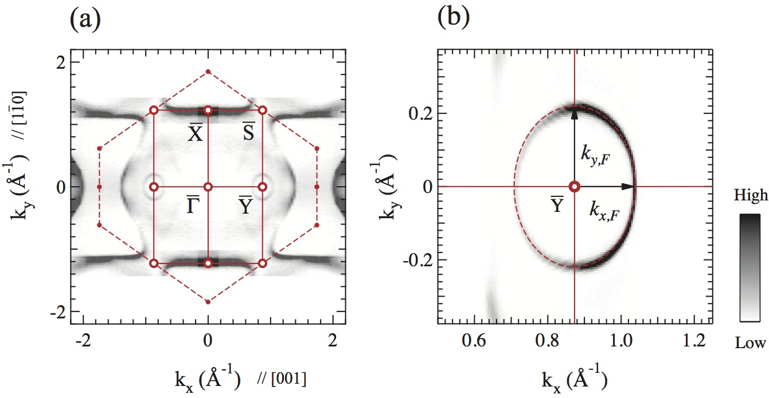

Fig. 1. This is the Style for Figure Captions. All text should be 10 pt. Justify this text under the figure [1]. If figures have more than one part, each part should be labeled (a), (b), etc.

References
[1] J. Jiang, S.S. Tsirkin, K. Shimada, et al. Phys. Rev. B 89, 085404 (2014).
[2] https://helpx.adobe.com/acrobat/using/pdf-fonts.html
[3] http://www.dessci.com/en/products/mathtype/

